Yawei laser World Tour (2) | America, Canada
2017-09-23 Yawei laser equipment division
Yawei laser equipment department concerned click me yo
Regularly push Yawei laser products, advanced technology, application technology, machine tool maintenance, the common problems of high quality content! It's right to pay attention to us.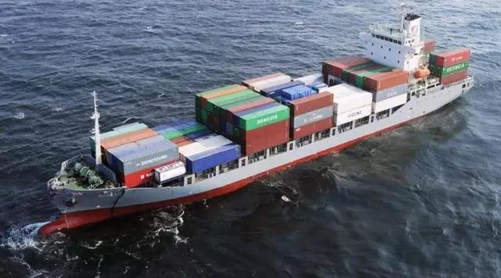
Yawei NC fiber laser cutting machine with reliable product quality, perfect price, superior competitiveness, are exported to Europe, America and Southeast Asia and other countries, by the trust of customers.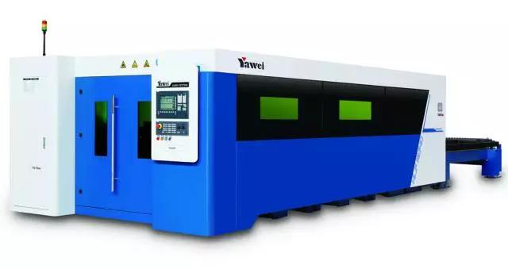
HLF series high speed optical fiber laser cutting machine
With the laser together enjoy Yawei laser cutting machine world tour:

A trip to the United States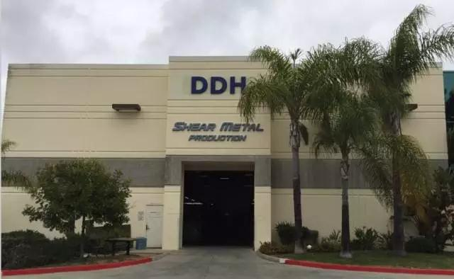
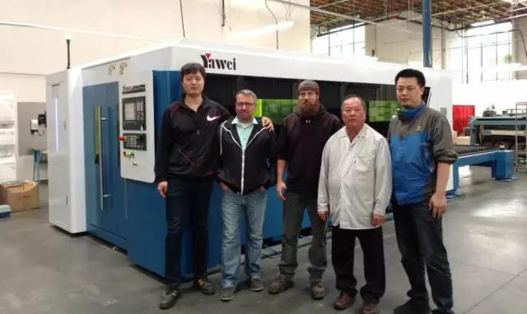
SHEAR METAL, USA

A trip to Canada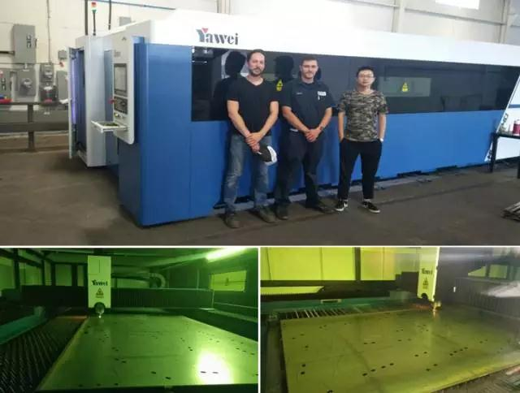
BRUNO, Canada
"To a more stable product Yawei laser equipment -" stable and efficient, timely service, in place!

Yawei fiber HLF series CNC laser cutting machine, is a set of years of research and development and innovation, Yawei laser fusion international forefront of laser technology, as the international level cutting machine.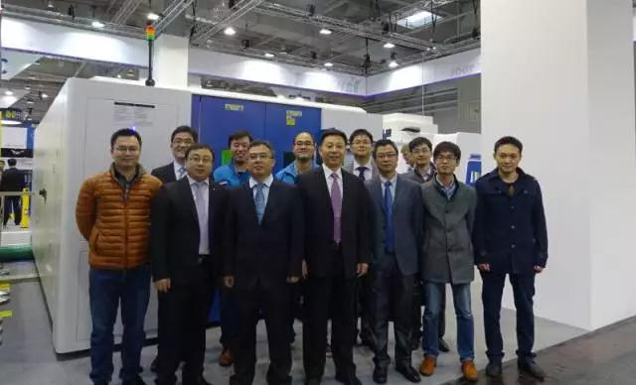
Yawei laser equipment department technical team

Yawei laser cutting machine world tour (3) will arrive in what country?
Please look at the next time you Yawei laser!

Hello, the partners can pay attention to us by two dimensional code.

